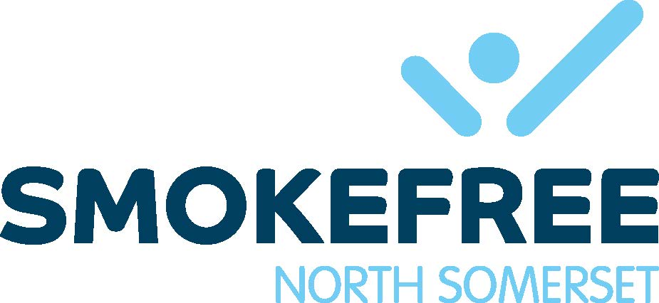

Zyban

Information for advisors

- Zyban is a non-nicotine preparation which reduces the urge to smoke by inhibiting re-uptake of dopamine and noradrenaline in the brain. It is an antidepressant, but its smoking cessation properties are unrelated to its antidepressant effects, and it is licensed in the UK only as a smoking cessation aid.
- Zyban is packaged in boxes of 60 x 150rng slow-release tablets (1 month's supply). It is licensed in the UK to be given as a 2-month course. Prescribe an 8-week course but at intervals so the client’s progress can be monitored closely. (1 month then a further month)
- Treatment is usually started while the patient is still smoking, and a quit date set for 1-2 weeks after the start of treatment.
- The dose is 150mg once a day. for 6 days, then 150mg twice daily.(8-hour lapse between tablets) for the rest of the course.
- The dose should be reduced to 150mg once daily. throughout the course if the patient is elderly or has mild to moderate renal or hepatic impairment.
- Zyban is not recommended for pregnant or breastfeeding women, nor currently for patients aged under 18 years.
- Zyban is contraindicated in patients who have:
- epilepsy or any history of seizures - known CNS tumour
- current or previous eating disorders - abrupt withdrawal from alcohol of benzodiazepines
- bipolar disorder - severe hepatic cirrhosis
- hypersensitivity to bupropion - recently taken MAOls (Monoamine oxidase inhibitors)
- Rarely (< 1 patient in 1,000) the drug can cause seizures. Caution should be exercised in patients who may have a lowered seizure threshold (e.g., previous head injury).
- Zyban appears to be well tolerated from a cardiovascular point of view. Since there is no clinical experience of the drug's use in patients immediately post myocardial infarction, however, caution has been advised in this group of patients.
- Common side effects include:
- dry mouth
- insomnia
- headache
- Gastrointestinal disturbance
- Patients using Zyban should be advised to avoid driving or operating machinery if they experience drowsiness as a result of taking the drug.
- Zyban has the potential to interact with the following classes of drug:
- antidepressants, e.g., imipramine, paroxetine - antipsychotics, e.g. thioridazine
- beta-blockers, e.g., metoprolol - type lc antiarrhythmics, e.g. flecainide
- levodopa - theophylline’s
- MAOIs - hepatic enzyme inducers or inhibitors, e.g. cimetidine
- drugs lowering seizure threshold, e.g., systemic steroids, quinolone antibiotics
- antimalarials - tramadol - quinolones - sedating antihistamines
- If Zyban is used in combination with NRT patches, weekly monitoring of blood pressure is recommended, as in one study a rise in BP was reported.
- Zyban must not be used in patients with predisposing risk factors unless there is a compelling clinical justification for which the potential medical benefit of smoking cessation outweighs the potential increased risk of seizure. All patients should be assessed for predisposing risk factors.

- The pharmacology of St John’s Wort evidence suggests that it may interact with other medicines, either by affecting drug metabolism or levels of neurotransmitters. Drug metabolism may be affected by St John’s Wort inducing certain cytochrome P450 isoenzymes in the liver (CYP3A4, 1A2 and 2C9) as well as P-glycoprotein. Pharmacodynamic interactions may occur through effects of St John’s Wort on neurotransmitters – St John’s Wort may increase serotonin levels through weak monoamine oxidase inhibiting (MAOI) activity and serotonin re-uptake inhibition.

Until more information becomes available, the use of Zyban in combination with St John’s Wort is not recommended.

