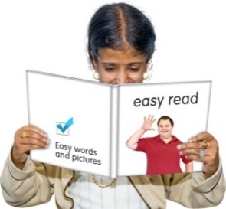
Easy Words and Pictures

Being Active
A guide for people with impairments or health conditions.

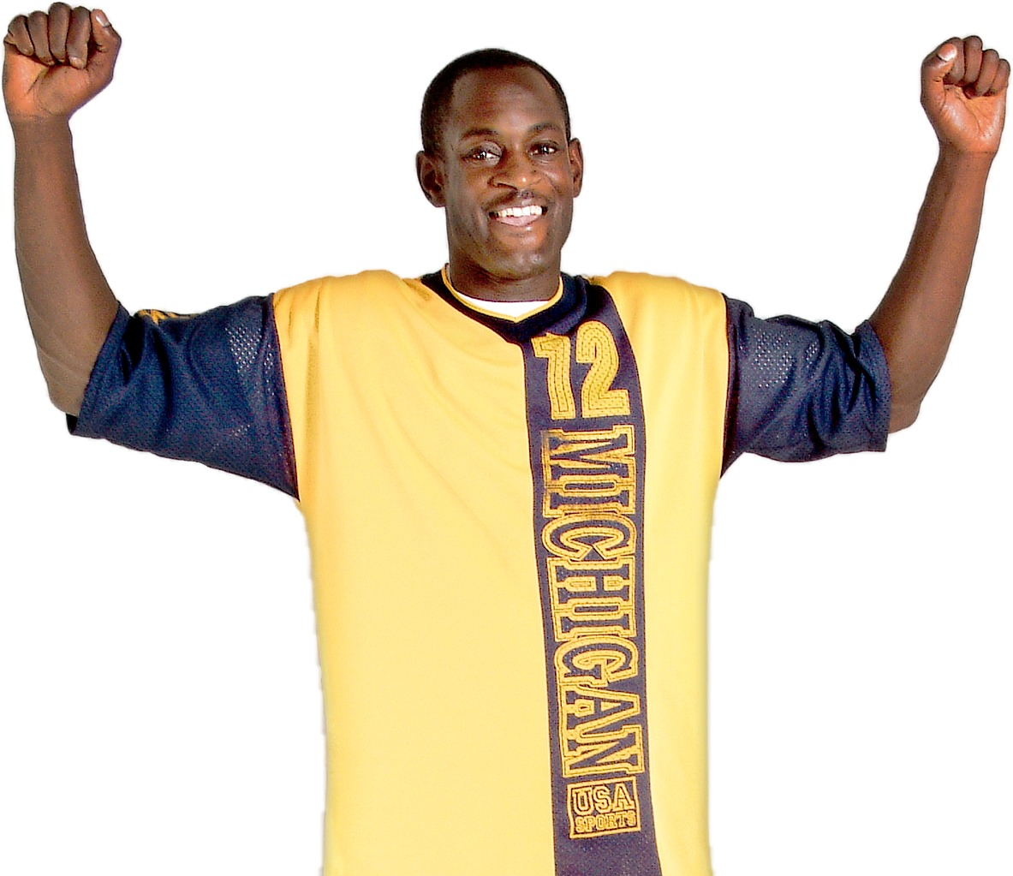
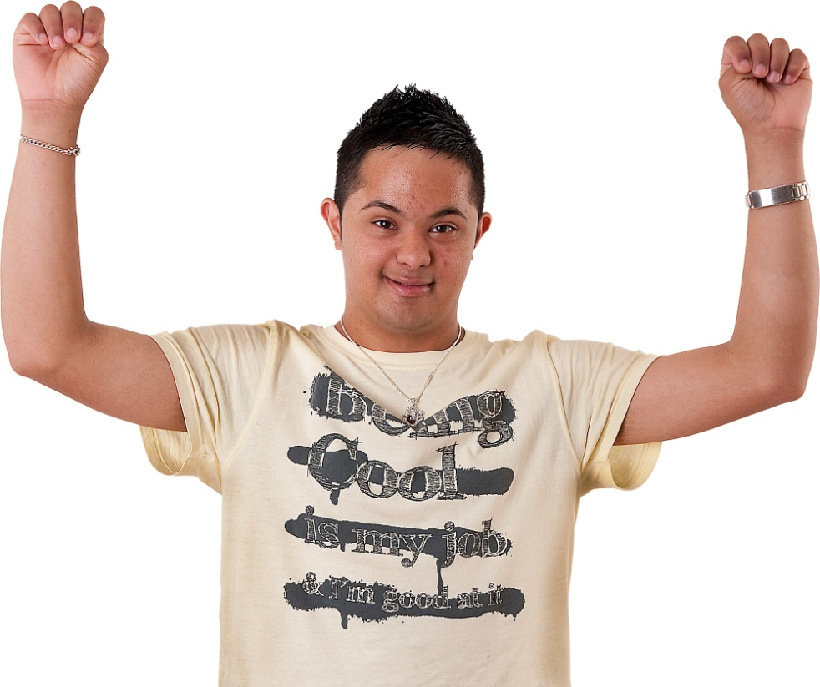

This guide is from Activity Alliance and Disability Rights UK (DRUK).
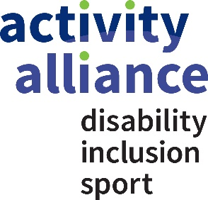
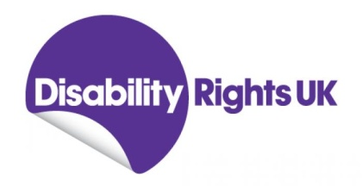
December 2014
Introduction

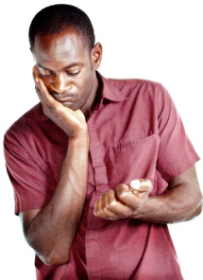

Most people are not as active as they want to be and do not exercise regularly.

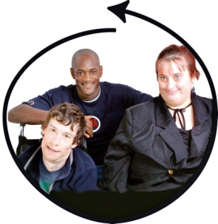
Exercising and keeping active is important.

It improves your health and gives you the chance to meet new people.

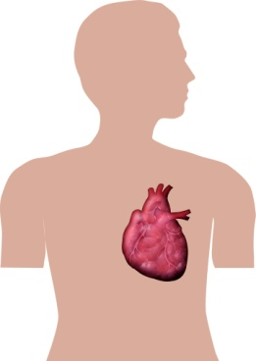
Having health conditions or disability can make it difficult to get involved in activities and exercise.
?

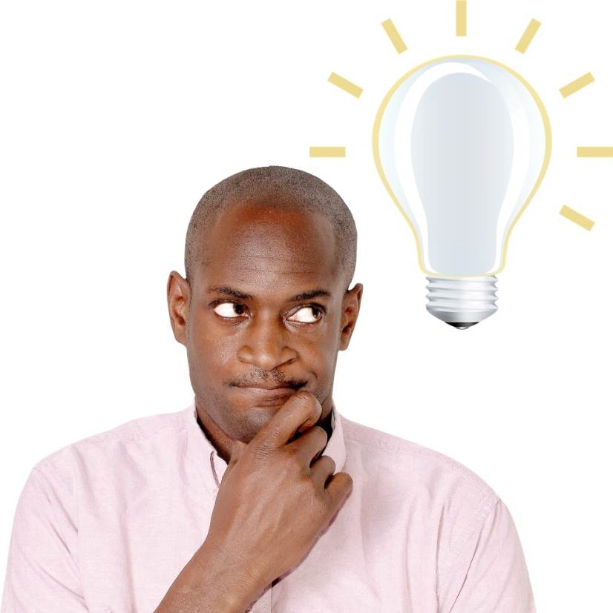
This guide gives you ideas on what you can do to be more active and exercise regularly.

In this guide

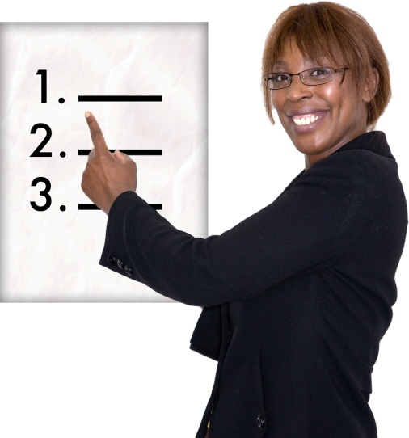
Why should I be more active? – Page 4

How do I get more active? – Page 6

What activities should I do? – Page 11

Where can I find out more? – Page 17

Why should I be more active?
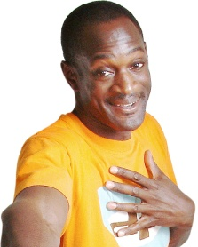

Being active is good for your health and well-being physically and mentally.
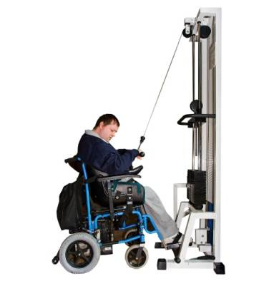

Having a health condition or impairment may affect what you can do but you can still try.

Being active will make a fitter, healthier you!

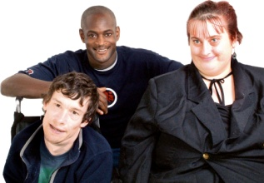
It also helps you meet people and make new friends.

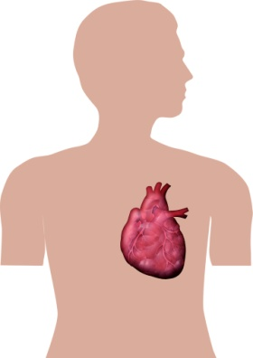
People who exercise regularly will enjoy these health benefits:
- lower risk of early death
- lower risk of heart disease and strokes

- lower risk of type 2 diabetes
- lower risk of colon cancer
- lower risk of depression
- lower risk of dementia

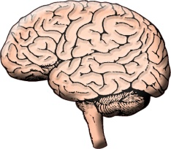
It also improves your memory and brain, reduces stress and helps you sleep.

Experts say it is best to exercise with friends or in a group and to exercise outside if possible.

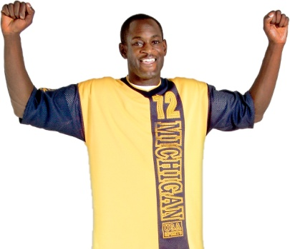
Exercise should be fun, even if it is hard at first!

It may tire you out in the short term but over time it will give you more energy.

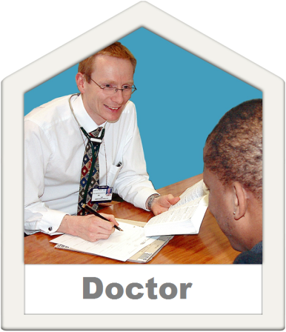

Your GP can help you find a local exercise or activity group.

How do I get more active?

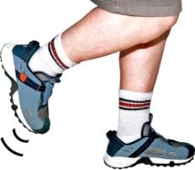
If you haven’t exercised recently then start with small exercises and slowly build up.

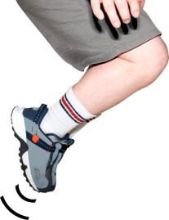
Remember one simple rule: Don’t do more now than you’ll be able to do tomorrow.

If you experience any pain or get dizzy then stop and see a doctor.

When exercising you should feel a burning sensation in your muscles but not pain.

If something hurts then stop doing it!
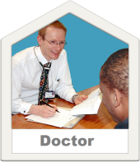

You should also check with your doctor if there are any activities he or she thinks might be unsafe.

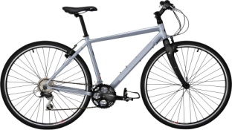
Choose an exercise or activity you enjoy and that gets your heart going a little.
?

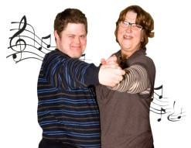
Each day do a little more of it.
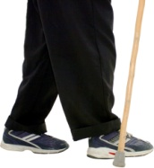

It does not have to be sport, it could be walking, dancing, riding a bike or a horse for example.

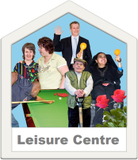

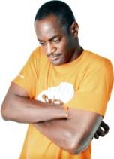

If you feel that you are being excluded because of your disability the law may be able to help you.

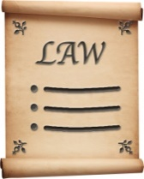
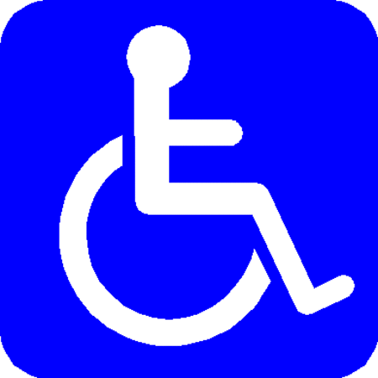
Most sports centres, clubs, rinks and venues must make reasonable adjustments for their disabled customers.

Most places are happy to make adjustments for you.

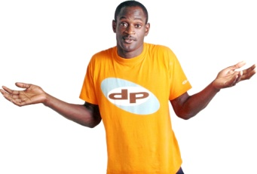
You know what you need better than anyone else so don’t be afraid to ask!

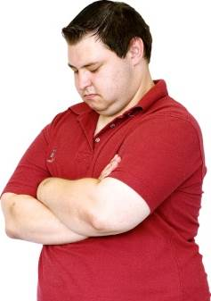
?

Sometimes we stop ourselves from being more active.

For example:
- You don’t like exercise
- You don’t like getting sweaty
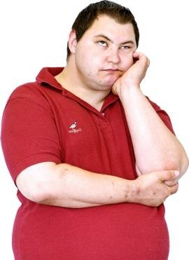
- You might look silly
- You’re too busy
- Your condition or impairment stops you exercising

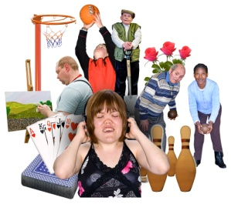

There is always some form of activity or exercise you can do.
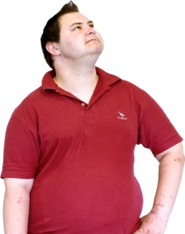

It could be something you already do or you could try something new.

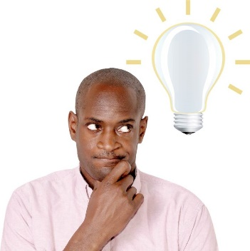
If you want to try something new you could make your own adjustments, for example:

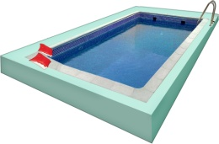
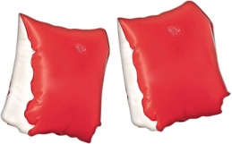
If you enjoy the pool but cannot swim you could try going with arm bands or a rubber ring.

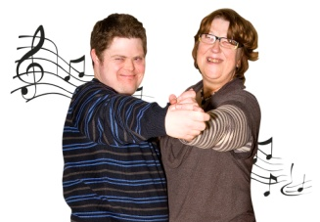
If you like to dance but are embarrassed in the class, try dancing at home.

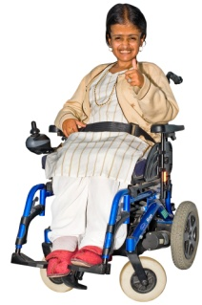
If you use a wheelchair you might think your options are limited.

However, this is not the case.

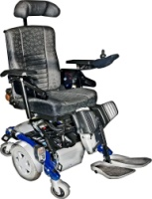
It is important to strengthen your shoulders and back.

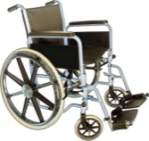
If possible, try using a manual wheelchair instead of electric.

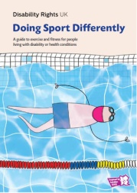
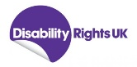
You could join one of the many organised wheelchair sports clubs. For more information take a look at Disability Rights UK’s publication Doing Sport Differently.

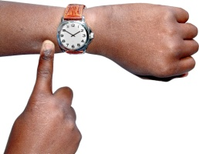
?
Even if you think you’re too busy there is more you can do.

You do not have to dedicate hours to do being more active.

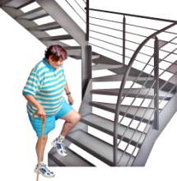
Below are some everyday examples of things you can do:
- Use the stairs instead of the lift
- Walk to the shops instead of using the bus
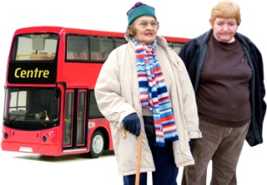
- Get off the bus early and walk the last stop
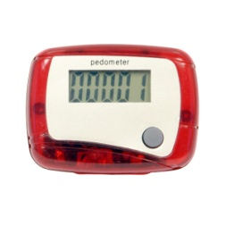
- Go walking with friends instead of meeting for coffee
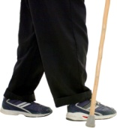
- Count your steps using a Pedometer, then try to do more the next day
- Do something active during your free time
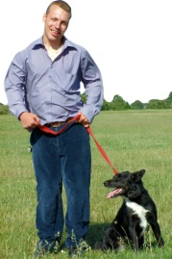
- Exercise with a friend or even your dog
- Exercise when you’re doing the housework or gardening
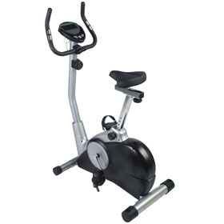
- Enjoy outdoor activities with your family
- Use an exercise bike while watching TV

What activities should I do?

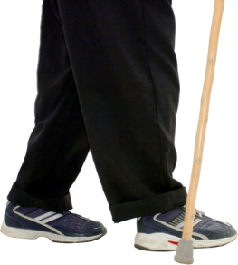
Walking

If you can walk it is good exercise.

Some benefits of walking are:
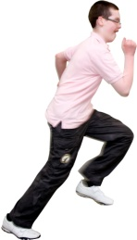
- You don’t need to warm up, you don’t need trainers and you don’t get sweaty
- You’re not likely to get injured
- It is easy to do it everyday

You can join walking or rambling groups if you want to meet other people to walk with.
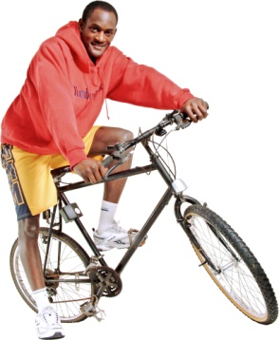

Cycling

You can use cycling as transport to get around.

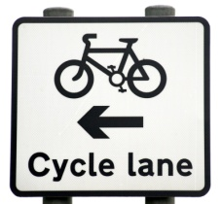
Cycling on the roads is dangerous but there are lots of cycling lanes and off-road places to use a bike.

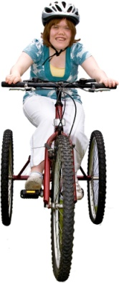
If you think your condition or impairment means you cannot use a bike you are probably wrong.

There is a huge variety of tricycles, quads, power assisted and other bikes which you may be able to use.

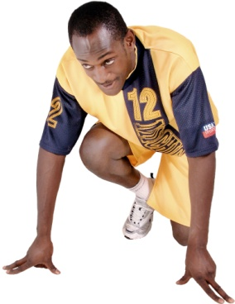
Running

Running is very good exercise but you must be careful not to get injured.

Take it easy and do not run too far or too fast.

Always warm up with some walking and stretching.

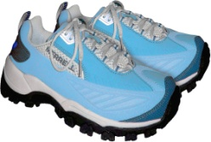
Always wear running shoes that fit properly.

Remember, don’t do more today than you will be able to do tomorrow.

Exercise at home

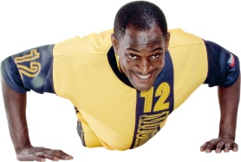
You can exercise at home without any equipment.

You could do sit ups, press ups or squats.

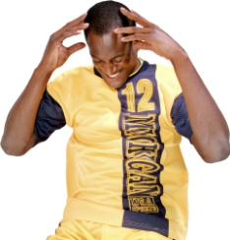
Or you can use equipment to help you such as a Wii or a fitness DVD.

As little as 10 minutes a day will help.

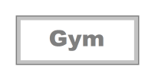
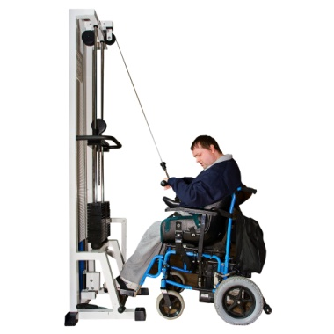
Joining a Gym

The Inclusive Fitness Initiative has approved over 400 gyms in the UK.

This means their staff and facilities include disabled people.
?

You can search for the gyms here www.activityalliance.org.uk/get-active/inclusive-gyms

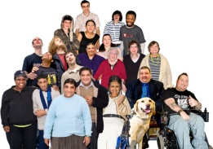
Before you join visit the gym and ask yourself:
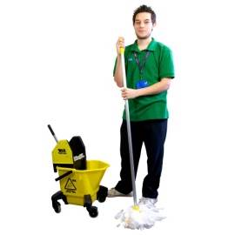
- Is it too crowded?
- Is it clean?
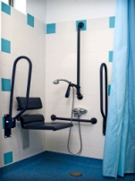
- Is the equipment suitable?
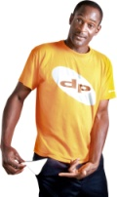
- Are the staff experienced with disabled people?
- Can you afford the fees?

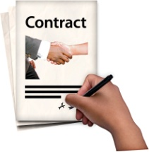
If you are happy then ask the gym for a trial before you sign the contract.

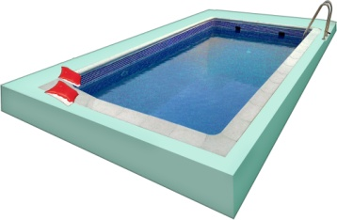
Swimming

Swimming is a good activity with a low risk of injury.

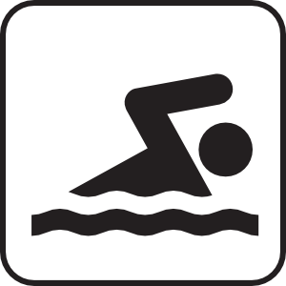
Plus your body is supported by the water so it can be easier to move.

It is popular with disabled people.

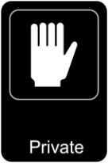
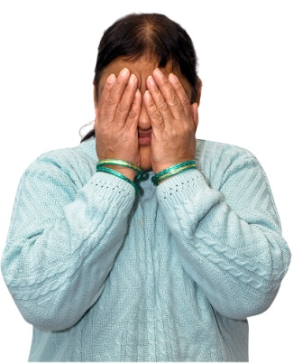
Some people like it because less people can see your body when you’re under water.

Other sports

There are many sports and clubs for disabled and non-disabled people alike.

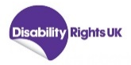
You can find out more information on Activity Alliance’s website www.activityalliance.org.uk in ‘Doing Sport Differently’ published by Disability Rights UK.
Something more gentle?

Slower and less energetic activities like Yoga and Tai-Chi will improve health without risking injury.
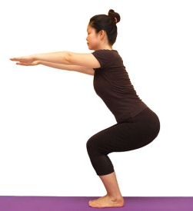

These activities are about balancing and positioning your body.

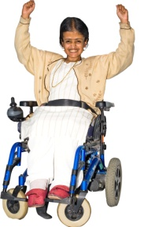
They will increase your balance, strength and energy.

Older people

Think about gentle exercise such as walking or Yoga.

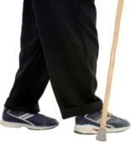
You can find special classes or senior playgrounds with specialist equipment.

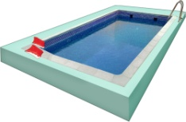
You could try swimming, dancing or even just learning some stretches.

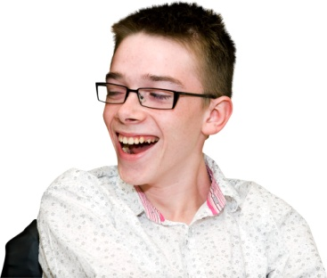

Younger people

Most activities are available to you somewhere.

Think about what you want to do and what is safe for you to do.

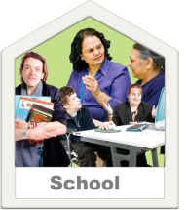
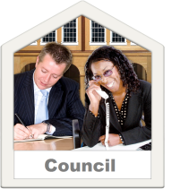
Talk to you school or council and they will help you find activities locally.

Where can I find out more?

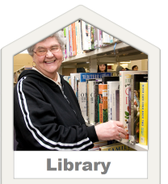
To find out more about activities in your area you can start by asking at your local library, council or social services department.

Below is a list of websites to help you find more activities:
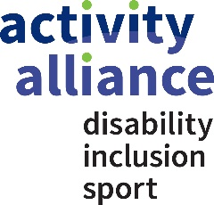

- Activity Alliance
www.activityalliance.org.uk
(Activity Alliance is the operating name for the English Federation of Disability Sport.)

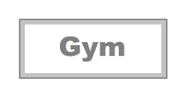
- Find an inclusive Gym www.activityalliance.org.uk/get-active/inclusive-gyms

- BBC
www.bbc.co.uk/thingstodo/activities

- County Sports Partnership Network
www.cspnetwork.org

- Parasport
www.parasport.org.uk

Below is a list of website links to help you find disability sports organisations:

- British Blind Sport
www.britishblindsport.org.uk
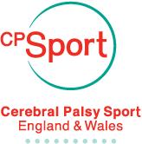
- Cerebral Palsy Sport
www.cpsport.org
- Dwarf Sports Association
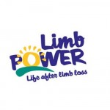
www.dsauk.org

- Limbpower
www.limbpower.com

- Mencap Sport
www.mencap.org.uk/what-we-do/our-services/leisure/mencap-sport
- Special Olympics GB
www.specialolympicsgb.org.uk
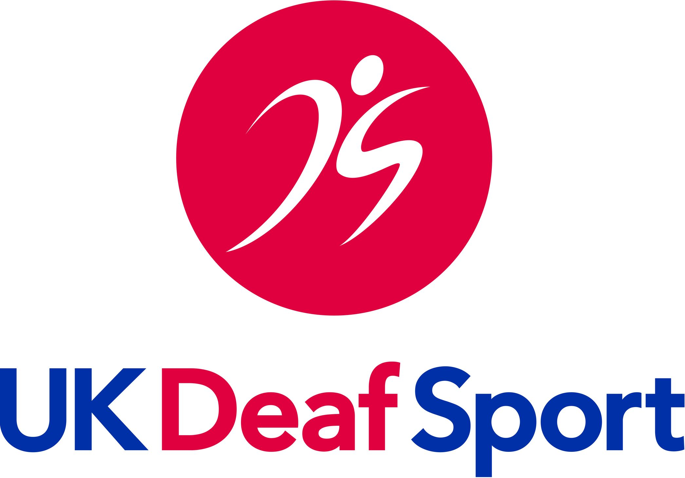
- UK Deaf Sport
www.ukdeafsport.org.uk

- WheelPower
www.wheelpower.org.uk

Below is a list of website links to help find activities for children and young people:

- Whizz-Kidz - disabled children's charity
www.whizz-kidz.org.uk
- NDCS – National Deaf Children’s Society
www.ndcs.org.uk
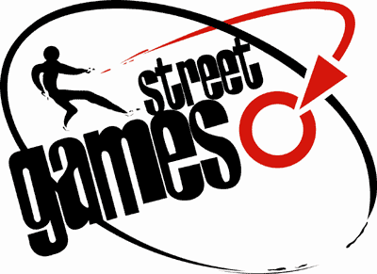
- StreetGames
www.streetgames.org

Below is a website link to help find activities for older people:

- Age UK
www.ageuk.org.uk/health-wellbeing/keeping-fit/

You can also use the internet and social media, such as Facebook, to check for local activities.

