
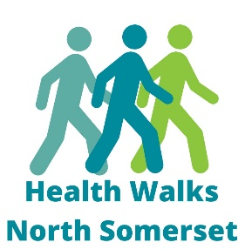
Group | Contact Name | Contact Number/email
Churchill and Cheddar | Adrian and Sandi | 01934 743 527 / adrianmale99@gmail.com
Clevedon | Lynne | 01275 852 663
Long Ashton | Ruth | 07814 671 369
Nailsea | Julia | 07413 449839
Portishead | Chris | 01275 845 736
Weston-s-Mare | John | 01934 511 808
Winscombe | Dawn | 07376 126 473
Yatton | Marion | 07967 346 188
Health Walk Leader Contacts

