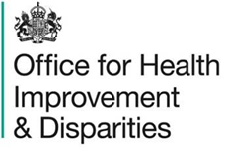
LA name: _______________________________

Early years setting: ____________________________

Setting postcode: ________________________

Child ID number: _________________________


National Dental Survey, 2026 to 2027

I have read and understood the information for parents and persons with parental responsibility


I agree to my child having a dental check as part of the national dental survey 2026 to 2027

Child’s full name: ____________________________________________

Child’s date of birth: _________________________________________

Child’s home postcode: ______________________________________

Additional fields to record ethnicity or other data, may be added here if this cannot be sourced from the early years setting.

Name of parent or person with parental responsibility: _____________

Signature of parent or person with parental responsibility: _________

Date:__________________________

Please return this form to your child’s early years setting. Thank you.
Please let staff know if you have already agreed to your child participating in this year's survey at a different setting they attend.

